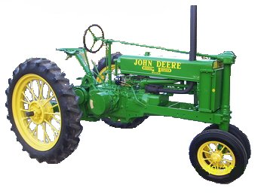
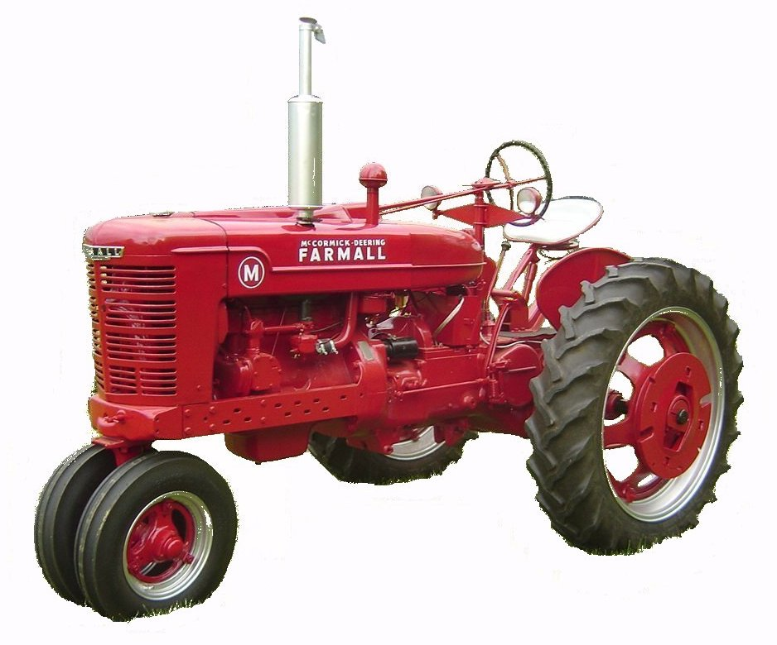
F O O T H I L L S

ANTIQUE POWER ASSOCIATION
ESTABLISHED 2003

Dear Members, May 2016
The show is just about to begin. This newsletter is an abbreviated one to try to get all the pertinent information to you. Please read over all of it. There have been a few changes from last year. We pray for good weather, good crowds, safety for everyone, and a great time for all involved. Looking forward to seeing you all there.

--- --- --- From the April Meeting --- --- ---

- We continue to have many who are in need of special prayer. We trust God to care for them as only He can, whether it be healing, or for comfort and strength to living in the midst of affliction. We cast our cares on Him, for He cares for us.

  - Kelly Blanton
  - Dot Hawn
  - Butch Minyard
  - Rev. Bobby Langston
  - Allen Everdyke
  - Lorna Sheets
  - Charles Huffman
  - Steve Hefner
  - Wade Hefner
  - Norris Turner
  - Don Johnson
  - Carl Porter
  - Jane Abernathy
  - Terry Martin
  - Eugene Hartley
  - Ira & Ann Cline
  - Carroll Hilliard
  - Howard Cooper
  - Charles Elmore
  - Ann Little
  - Charles Bentley
  - Kenneth Beach
  - Powell Sigmon
  - Vee Williams

- A few specific items need to be emphasized as we come down to the wire.
  - For all members having reserved spaces at the fairgrounds, we will do the same as last year: if you have not placed your equipment on your space by Friday at noon, the space(s) will be reassigned as needed for the remainder of the show, that is, unless you inform Teddy Hefner or Anthony Austin that you will be late arriving.
    - Being up-to-date on your membership is a primary criteria for being able to reserve a space at the show.
    - If you have not used your space in some time, please consider relinquishing it so someone else can use it. Let Teddy or Anthony know by 12 noon Friday. We are considering canceling specific reserved spaces if they have not been used in a couple years – it’s only fair, if you don’t want to use your space, someone else can. Having empty spaces in the show grounds is not good.
    - If you cannot to use them this year, please inform Teddy or Anthony also by 12 noon Friday, so he can temporarily provide someone else the opportunity to show their equipment this year. We want to do all we can to fill the display area.

  - Everyone planning to use electric power during the show – vendor, exhibitor, member or non-member – is required to pay a $25 power fee. This is not our requirement, but the fair board and the funds collected go directly to the fair treasury to pay the electric power bill. Charles Bentley is in charge of collecting these fees. If you do not pay him ahead of time, he will find you during the show and collect the fee!
  - Golf carts will be available to rent. If you’d like to rent one for the weekend, go ahead and contact Golf Carts of Hickory, and he’ll set you up. At the show Howard Reinhardt will be handling daily rentals. You can find him in the store building.
  - Enclosed you will find a small colored tag to place in your windshield (as we’ve done in the past). That way the ushers can easily see you are a member.
  - On the last page of this letter you will find a list of guidelines and rules we need to all be aware of and adhere to so we can make sure our show is a safe and pleasant one for everyone. Please familiarize yourself with them.

☺ ☺ !!!!! HAPPY BIRTHDAY !!!!! ☺ ☺


May birthdays

1 – Ben Elmore
2 – Allen Keller
3 – Jason Ball
4 – Jason Dagenhardt
7 – Terry Rodland
8 – Jimmy Milsaps
20 – Brad Hawes
24 – Donna Lauterbach
24 – Dylan Roseman

25 – Paul Pope
28 – Gene Carpenter
29 – Clark Davis
30 – Gale Wilson

June birthdays

1 – Mark Cunningham
1 – Larry E. Davis
2 – Ned Story
5 – Butch McIntyre
6 – Ron Bachman
6 – Alton Reed
9 – Danny Joe Little
9 – Barry Matthews
10 – Roger Matlock
11 – Tony Sigmon
13 – Keith Schronce
14 – John Bumgarner
16 – Andy Parsons

21 – Michael McAlister
24 – Billie Herman
26 – Marcus Strickland
29 – Carroll Reed
30 – Robert Hindman
30 – Myron Yount

-- --- --- THE CLASSIFIEDS --- --- ---

Is there anything you would like to sell or are you looking for something special? List it here.
(Item listings will run for 3 months before expiring. Let us know when an item is sold or bought.)

FOR SALE

1948 Ford 8N, fully restored, 828-323-5743 (16-03).

1939-54 Ford front bumper, $100 828-612-2059 (15-03).

--- --- --- UP-COMING EVENTS --- --- ---

May 20-21 Newton FAPA 13th Annual Antique Power Show
June 11 Newton CVHA Wheat Harvest Show
Due to several unforeseen circumstances, some of the responsibilities and duties have changed hands. These are the ones you want to go to for help with something, or to be a help with something.

▪ Club trailer steward: Wilson Sigmon.
▪ Registration trailer transport: Art Henderson
▪ Registration: Amy Huffman, Reba Reinhardt
▪ Crafts coordinator: Howard Reinhardt.
▪ Program coordinator (layout, printing, etc.): Kevin & Erin Sigmon
▪ Program ad coordinator: Wilson Sigmon.
▪ Tee-shirt sales coordinator: Donnie & Janice Elmore
▪ Tee-shirt coordinator (design layout/printing): Wilson Sigmon ▪ Storekeeper: Howard Reinhardt.
▪ Gate coordinator: Ben Elmore.
▪ Media coordinator: Wilson Sigmon, David Setzer, Howard Reinhardt
▪ Sign & banner steward: Bill Harris & Ned Story.
▪ Reserved Space coordinator: Teddy Hefner & Anthony Austin
▪ Exhibitor usher: Foster Edgar, Ray Weaver
▪ Pulling track prep & maintenance: Butch McIntyre.
▪ Blacksmith: Bob Moose.
▪ Kiddie Pull: James Reinhardt.
▪ Pole shed steward: Bill Harris, Teddy Hefner, & Jim Yount.
▪ Sawmill overseer: Dale Reese, Billy Herman, and Ben Elmore.
▪ Parking & trash pickup coordinator: Alan Keller.
▪ Electric power usage fee collector: Charles Bentley
▪ PA system steward: Brandon Sigmon.
▪ Demonstration exhibit coordinator: David Setzer.
▪ Wagon coordinators: Philip Spencer, Jim Yount
▪ Food vendor coordinator: Charles Bentley.
▪ Tractor Rodeo coordinator: Kevin Black & B.J.Moretz
President: Kevin Black 828-464-1950 Vice Pres: Wilson Sigmon 828-256-2176
Treasurer: Kermit Nash 828-459-9616 Secretary: David Setzer 828-850-4943
Show Chair: Ned Story 828-464-6399 Asst.Show Chair: Teddy Hefner 828-310-5525
Asst. Secretary: Kevin Sigmon 828-256-2176

--- --- --- a thought for the show --- --- ---

I can think of no better thing to think about, no more appropriate thing to do, nor any more succinct words to say at this point, not only in preparation for our show, but during the show, and after the show, than the words of Psalm 117.
Oh, praise the LORD, all ye nations;
Praise him, all ye people.
For his merciful kindness is great toward us;
And the truth of the LORD endureth forever.
Praise ye the LORD.
God bless you all. See you at the show.
Your Secretary,
David Setzer

Foothills Antique Power Assoc. 13th Power Show May 20 – 21, 2016

- Set-up time at the American Legion Fairgrounds will begin Thursday afternoon May 19th after the Flea-market clean-up has been completed and the grounds have been prepared. Actual time for opening the gates for setup may be between 4 or 5PM depending upon when clean-up is completed. If it is finished early, the time can be moved up.
- Spaces in the main exhibit area may be reserved by members in good standing (dues paid). These spaces are to be occupied by 12 noon on Friday May 20 or they will be forfeited for the duration of the show (unless your intent to fill them after that time is communicated to the reserved space coordinator – Teddy Hefner (310-5525).
- All members are to be aware of and adhere to the safety requirements for the show.
- All members are called upon to function as safety monitors by presenting your own exhibits in a safe manner and helping each other do the same.
  - All equipment is to be chocked when parked. Chocks will be available if you have none.
  - Fire extinguishers are to be ready at hand.
  - Be aware of and yield to pedestrians when driving any vehicle on the grounds.
  - Demonstrations should be roped-off to keep little fingers on little hands where they belong.
- Plenty of parking is available, but we need to utilize it wisely.
  - Trailers should be parked in the area behind the livestock barn.
  - Towing vehicles should be parked in the general parking area.
  - The area next to the pulling track is for pullers (Friday & Saturday)
- All exhibitors are encouraged to register.
- All exhibitors are encouraged to operate their equipment during the show except for two specific times. During these times, all engines, tractors, mowers, etc. are requested to be turned off.
  - During opening ceremonies on Saturday morning.
  - During Sunday morning church services.
- The route for the Parade of Power will be marked off with signs. Everyone should begin by exiting the Main Exhibit area through the pulling track parking area, cross the main road and proceed through the main parking area to the back gate, then through the food court area.
- This is our show. That means we are host to the public and to those who come to exhibit with us. It is up to every one of us to do what we can to make it a memorable experience for all who come. Each member is encouraged to do their part – no task is too small or menial to be worthwhile and every person is worthy of a smile or a helping hand.
- Basic schedule of events
  - Friday: Lawn mower pull - 7PM
  - Saturday: Opening Ceremony - 9AM
      - Demonstrations – 10AM thru mid-afternoon
      - Parade of Power – 1PM
      - Tractor Rodeo – 3PM
      - OTTPA Truck/Tractor Pull – 5PM
  - Sunday: Church service – 9:30A

